

Vidyavardhini’s

**College of Engineering & Technology**

Vasai Road (W)

**Department of Artificial Intelligence & Data Science**

**Laboratory Manual Student Copy**

|  |  |  |  |
| --- | --- | --- | --- |
| Semester | III | Class | S.E. |
| Course Code | CSL304 | | |
| Course Name | Skill based Lab Course: Object Oriented Programming with Java | | |



**Vidyavardhini’s College of Engineering & Technology**

**Vision**

To be a premier institution of technical education; always aiming at becoming a valuable resource for industry and society.

**Mission**

* To provide technologically inspiring environment for learning.
* To promote creativity, innovation and professional activities.
* To inculcate ethical and moral values.
* To cater personal, professional and societal needs through quality education.

# Department Vision:

To foster proficient artificial intelligence and data science professionals, making remarkable contributions to industry and society.

# Department Mission:

* To encourage innovation and creativity with rational thinking for solving the challenges in emerging areas.
* To inculcate standard industrial practices and security norms while dealing with Data.
* To develop sustainable Artificial Intelligence systems for the benefit of various sectors.

# Program Specific Outcomes (PSOs):

PSO1: Analyze the current trends in the field of Artificial Intelligence & Data Science and convey their findings by presenting / publishing at a national / international forum.

PSO2: Design and develop Artificial Intelligence & Data Science based solutions and applications for the problems in the different domains catering to industry and society.

# Program Outcomes (POs):

Engineering Graduates will be able to:

* **PO1. Engineering knowledge:** Apply the knowledge of mathematics, science, engineering fundamentals, and an engineering specialization to the solution of complex engineering problems.
* **PO2. Problem analysis:** Identify, formulate, review research literature, and analyze complex engineering problems reaching substantiated conclusions using first principles of mathematics, natural sciences, and engineering sciences.
* **PO3. Design/development of solutions:** Design solutions for complex engineering problems and design system components or processes that meet the specified needs with appropriate consideration for the public health and safety, and the cultural, societal, and environmental considerations.
* **PO4. Conduct investigations of complex problems:** Use research-based knowledge and research methods including design of experiments, analysis and interpretation of data, and synthesis of the information to provide valid conclusions.
* **PO5. Modern tool usage:** Create, select, and apply appropriate techniques, resources, and modern engineering and IT tools including prediction and modeling to complex engineering activities with an understanding of the limitations.
* **PO6. The engineer and society:** Apply reasoning informed by the contextual knowledge to assess societal, health, safety, legal and cultural issues and the consequent responsibilities relevant to the professional engineering practice.
* **PO7. Environment and sustainability:** Understand the impact of the professional engineering solutions in societal and environmental contexts, and demonstrate the knowledge of, and need for sustainable development.
* **PO8. Ethics:** Apply ethical principles and commit to professional ethics and responsibilities and norms of the engineering practice.
* **PO9. Individual and teamwork:** Function effectively as an individual, and as a member or leader in diverse teams, and in multidisciplinary settings.
* **PO10. Communication:** Communicate effectively on complex engineering activities with the engineering community and with society at large, such as, being able to comprehend and write effective reports and design documentation, make effective presentations, and give and receive clear instructions.
* **PO11. Project management and finance:** Demonstrate knowledge and understanding of the engineering and management principles and apply these to one’s own work, as a member and leader in a team, to manage projects and in multidisciplinary environments.
* **PO12. Life-long learning:** Recognize the need for and have the preparation and ability to engage in independent and life-long learning in the broadest context of technological change.

|  |  |
| --- | --- |
| 1 | To learn the basic concept of object-oriented programming |
| 2 | To study JAVA Programming language |
| 3 | To study various concepts of JAVA programming like multithreading, exception handling, packages etc. |
| 4 | To explain components of GUI based application. |

# Course Objective

|  |  |  |  |
| --- | --- | --- | --- |
| CO | At the end of course students will be able to: | **Action verbs** | **Bloom’s Level** |
| CSL304.1 | Apply the Object Oriented Programming and basic programming constructs for solving problems using JAVA. | Apply | Apply (level 3) |
| CSL304.2 | Apply the concept of packages, classes , objects and accept the input using Scanner and Buffered Reader Class. | Apply | Apply (level 3) |
| CSL304.3 | Apply the concept of strings, arrays, and vectors to perform various operations on sequential data. | Apply | Apply (level 3) |
| CSL304.4 | Apply the concept of inheritance as method overriding and interfaces for multiple inheritance. | Apply | Apply (level 3) |
| CSL304.5 | Apply the concept of exception handling using try, catch, finally, throw and throws and multithreading for thread management. | Apply | Apply (level 3) |
| CSL304.6 | Develop GUI based application using applets and AWT Controls. | Develop | Create (level  6) |

**Course Outcomes**

# Mapping of Experiments with Course Outcomes

|  |  |  |  |  |  |  |
| --- | --- | --- | --- | --- | --- | --- |
| **List of Experiments** | **Course Outcomes** | | | | | |
| **CSL304**  **.1** | **CSL304.2** | **CSL304.3** | **CSL304.4** | **CSL304.5** | **CSL304.6** |
| Implement a program using Basic programming constructs like branching and looping | 3 | - | - | - | - | - |
| Implement a program to accept the input from user using Scanner and Buffered Reader. | 3 | - | - | - | - | - |
| Implement a program that demonstrates the concepts of class and objects | - | 3 | - | - | - | - |
| Implement a program on method and constructor overloading. | - | 3 | - | - | - | - |
| Implement a program on Packages. | - | - | 3 | - | - | - |
| Implement a program on 2D array & strings functions. | - | - | 3 | - | - | - |
| Implement a program on single inheritance. | - | - | - | 3 | - | - |
| Implement a program on Multiple Inheritance with Interface. | **-** | **-** | - | 3 | **-** | **-** |
| Implement a program on Exception handling. | **-** | **-** | **-** | **-** | 3 | **-** |
| Implement a program on Multithreading. | - | - | - | - | 3 | - |
| Implement a program on Applet or AWT Controls. | - | - | - | - | - | 3 |
| Mini Project based on the content of the syllabus (Group of 2-3 students) | - | - | - | - | - | 3 |

**INDEX**

|  |  |  |  |  |  |
| --- | --- | --- | --- | --- | --- |
| **Sr.**  **No.** | **Name of Experiment** | **D.O.P.** | **D.O.C.** | **Page No.** | **Remark** |
| 1 | Implement a program using Basic programming constructs like branching and looping |  |  |  |  |
| 2 | Implement a program to accept the input from user using Scanner and Buffered Reader. |  |  |  |  |
| 3 | Implement a program that demonstrates the concepts of class and objects |  |  |  |  |
| 4 | Implement a program on method and constructor overloading. |  |  |  |  |
| 5 | Implement a program on Packages. |  |  |  |  |
| 6 | Implement a program on 2D array & strings functions. |  |  |  |  |
| 7 | Implement a program on single inheritance. |  |  |  |  |
| 8 | Implement a program on Multiple Inheritance with Interface. |  |  |  |  |
| 9 | Implement a program on Exception Handling. |  |  |  |  |
| 10 | Implement a program on Multithreading. |  |  |  |  |
| 11 | Implement a program on Applet or AWT Controls |  |  |  |  |
| 12 | Mini Project based on the content of the syllabus (Group of 2-3 students) |  |  |  |  |

D.O.P: Date of performance

D.O.C : Date of correction

|  |
| --- |
| Experiment No.1 |
| Basic programming constructs like branching and looping |
| Date of Performance: |
| Date of Submission: |

**Aim :-** To apply programming constructs of decision making and looping.

**Objective :-** To apply basic programming constructs like Branching and Looping for solving arithmetic problems like calculating factorial of a no entered by user at command prompt .

**Theory :-**

Programming constructs are basic building blocks that can be used to control computer programs. Most programs are built out of a fairly standard set of programming constructs. For example, to write a useful program, we need to be able to store values in variables, test these values against a condition, or loop through a set of instructions a certain number of times. Some of the basic program constructs include decision making and looping.

Decision Making in programming is similar to decision making in real life. In programming also we face some situations where we want a certain block of code to be executed when some condition is fulfilled. A programming language uses control statements to control the flow of execution of program based on certain conditions. These are used to cause the flow of execution to advance and branch based on changes to the state of a program.

* if
* if-else
* nested-if
* if-else-if
* switch-case
* break, continue

These statements allow you to control the flow of your program’s execution based upon conditions known only during run time.

A loop is a programming structure that repeats a sequence of instructions until a specific condition is met. Programmers use loops to cycle through values, add sums of numbers, repeat functions, and many other things. ... Two of the most common types of loops are the while loop and the for loop. The different ways of looping in programming languages are

* while
* do-while
* for loop
* Some languages have modified for loops for more convenience eg :- Modified for loop in java.

For and while loop is entry-controlled loops. Do-while is an exit-controlled loop.

**Code: -**

**1} while loop**

class Whileloop

{

public static void main(String args[])

{

int a=4;

while(a%2==0)

{

System.out.println("\n Number is even");

break;

}

} }

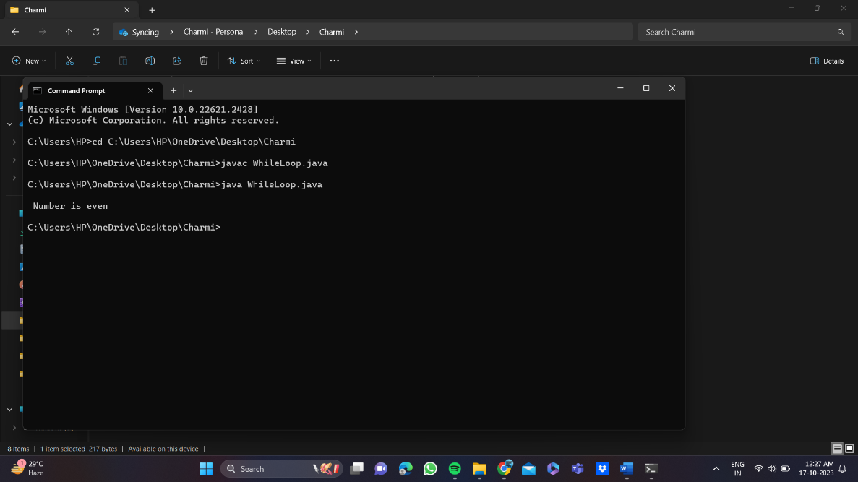

**2} for loop**

class Forloop

{

public static void main(String args[])

{

int x;

for(x=1;x<=10;x++)

{

System.out.println(x);

}

}

}

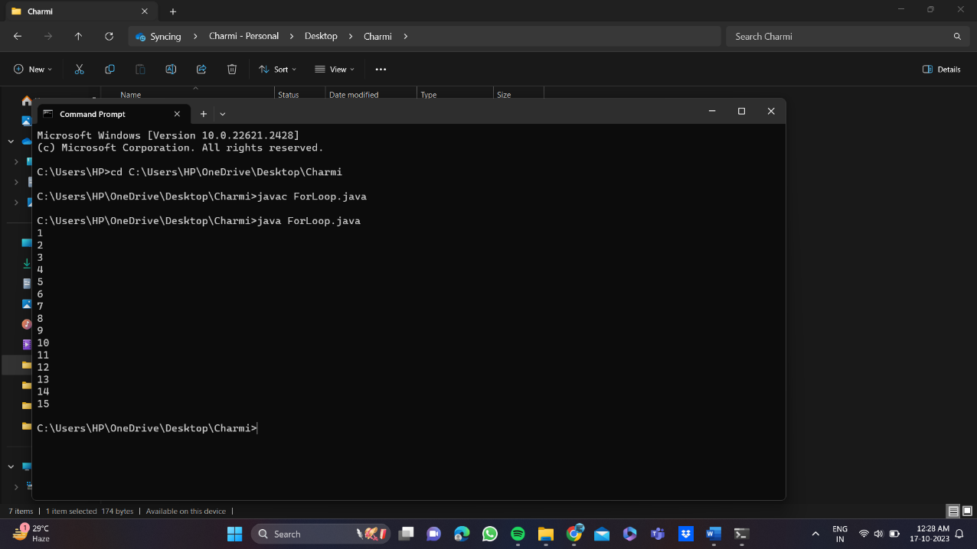

**3} dowhile loop**

class Dowhileloop

{

public static void main(String arg[])

{

int a=0;

do

{

if(a%20==0)

{

System.out.println(a);

} a++;

} while(a<=100);

}

}

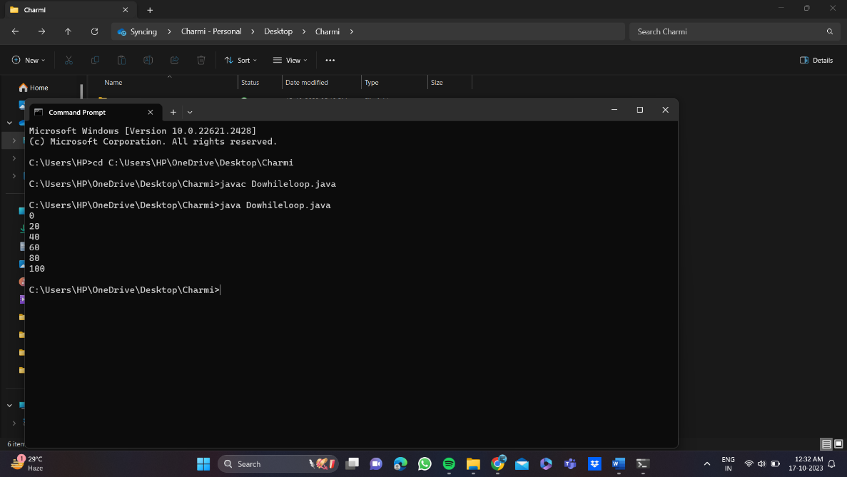

**4}if else**

public class IfElseExample {

public static void main(String[] args) {

int number=10;

if(number%2==0){

System.out.println("Even number");

}else{

System.out.println("Odd number");

}

}

}

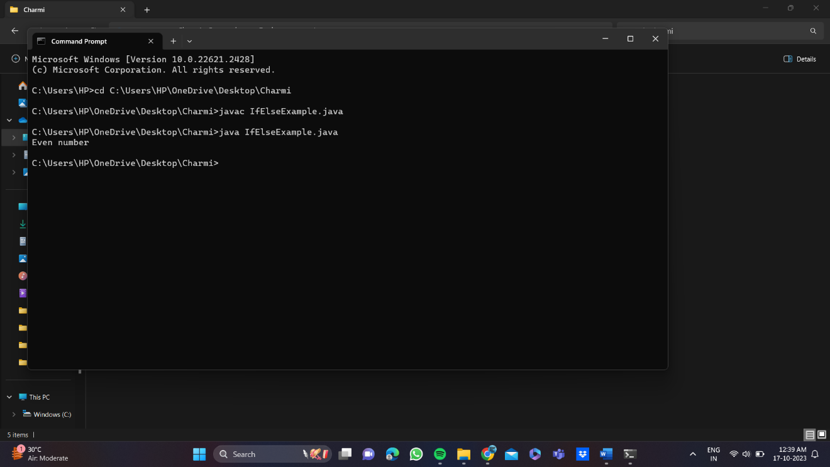

**5} Ladder if else**

class SecJavaProgram

{

public static void main(String args[])

{

int a=90;

if(a>=90)

{

System.out.println("grade A");

}

else if(a>=80)

{

System.out.println("grade B");

}

else if(a>=70)

{

System.out.println("grade c");

}

else if(a<70)

{

System.out.println("grade F");

}

}}

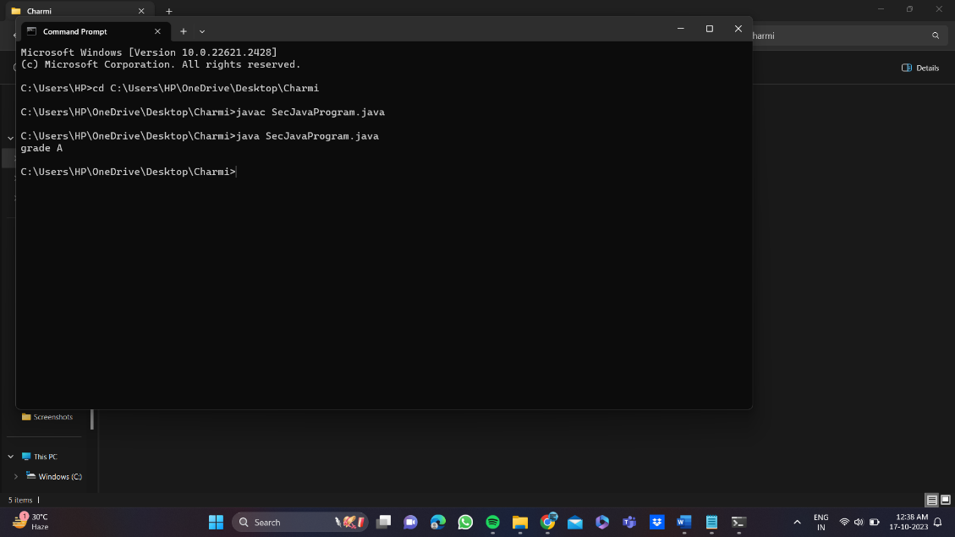

**6} nested if else**

public class PositiveNegativeExample {

public static void main(String[] args) {

int number=15;

if(number>0){

System.out.println("POSITIVE");

}else if(number<0){

System.out.println("NEGATIVE");

}else{

System.out.println("ZERO");

}

}}

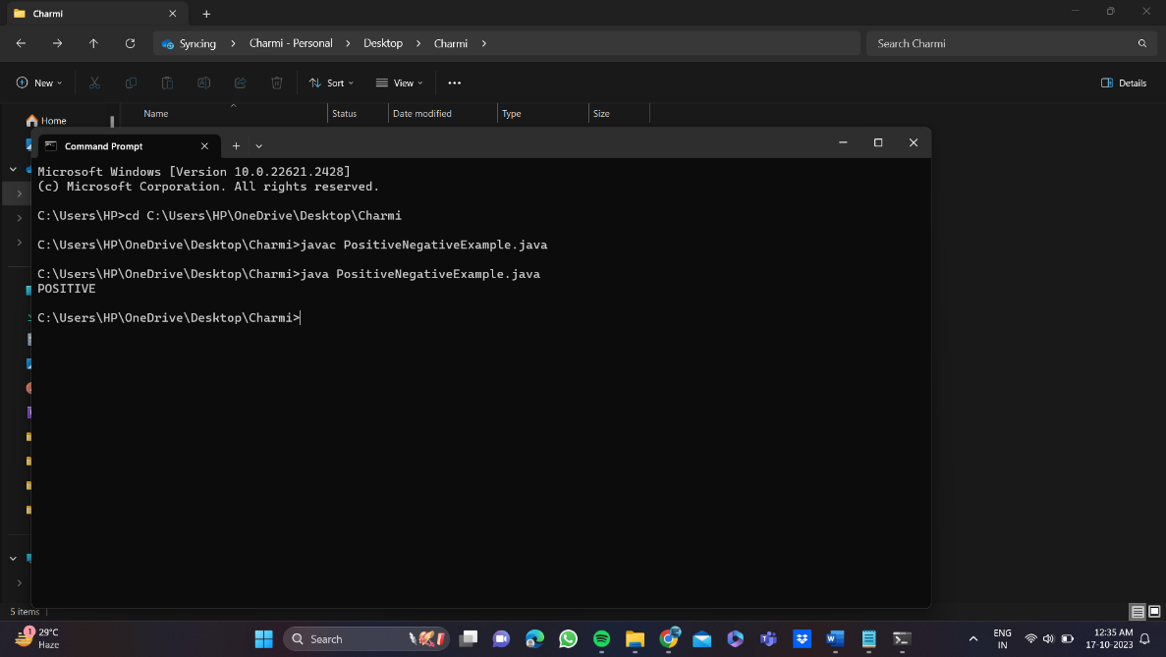

**7} switch**

class SwitchProgram

{

public static void main(String args[])

{

int a = 1 ;

switch(a)

{

case 1 :

System.out.println("\n Monday");

break;

case 2 :

System.out.println("\n Tuesday");

break;

case 3 :

System.out.println("\n Wednesday");

break;

case 4 :

System.out.println("\n Thursday");

break;

case 5 :

System.out.println("\n Friday");

break;

case 6 :

System.out.println("\n Saturday");

break;

case 7 :

System.out.println("\n Sunday");

break;

default :

System.out.println("\n Not Valid");

}

} }

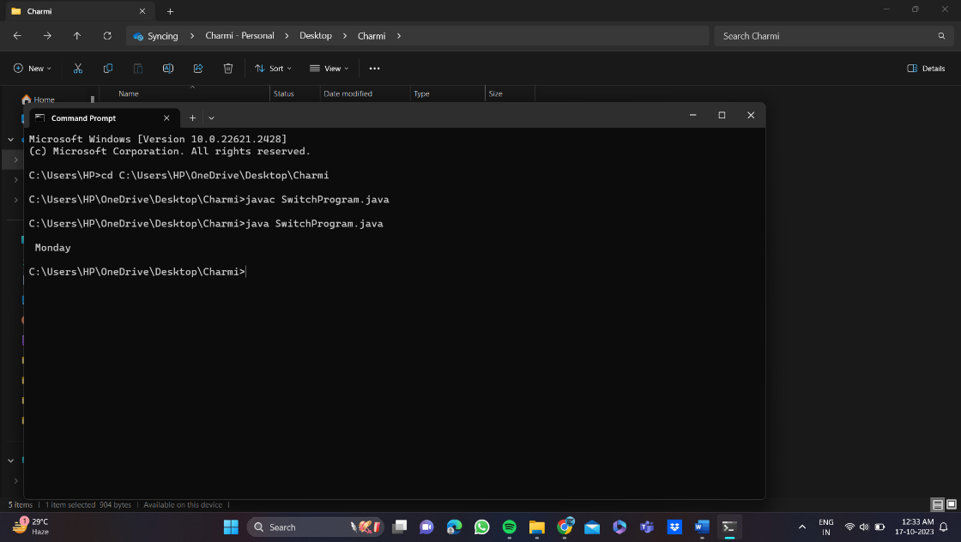

## Conclusion:

1) Comment on how branching and looping useful in solving problems.

* **Branching (Conditional Statements):**
* Decision Making: Conditional statements like if, else if, and switch allow you to make decisions in your code. You can choose different paths based on the values of variables or conditions, making it possible to solve problems with multiple possible outcomes.
* Error Handling: Exception handling with try, catch, finally, and throw allows you to gracefully handle errors, ensuring that your program doesn't crash when unexpected issues arise. This is crucial for robust problem-solving.
* Boolean Logic: You can use logical operators (e.g., &&, ||, !) to create complex conditions, which are often necessary for solving real-world problems that involve multiple criteria.
* **Looping (Iteration):**
* Repetition: Loops like for, while, and do-while enable you to execute a block of code repeatedly. This is invaluable for solving problems that involve processing a sequence of data or performing the same operation multiple times.
* Array and Collection Processing: When working with arrays, lists, or other collections, loops are essential for iterating through the elements and performing actions on each item. This is fundamental for data manipulation and analysis.
* Simplifying Code: Loops help avoid code duplication. Instead of writing the same code segment multiple times, you can encapsulate it within a loop and make your code more concise and maintainable.

|  |
| --- |
| Experiment No.2 |
| Accepting Input Through Keyboard |
| Date of Performance: |
| Date of Submission: |

**Aim:** To apply basic programing for accepting input through keyboard.

**Objective:** To use the facility of java to read data from the keyboard for any program

**Theory:**

Java brings various Streams with its I/O package that helps the user perform all the Java input-output operations. These streams support all types of objects, data types, characters, files, etc. to fully execute the I/O operations. Input in Java can be with certain methods mentioned below in the article.

Methods to Take Input in Java

There are two ways by which we can take Java input from the user or from a file

1. BufferedReader Class
2. Scanner Class

**Using BufferedReader Class for String Input In Java**

It is a simple class that is used to read a sequence of characters. It has a simple function that reads a character another read which reads, an array of characters, and a readLine() function which reads a line.

InputStreamReader() is a function that converts the input stream of bytes into a stream of characters so that it can be read as BufferedReader expects a stream of characters. BufferedReader can throw checked Exceptions.

**Using Scanner Class for Taking Input in Java**

It is an advanced version of BufferedReader which was added in later versions of Java. The scanner can read formatted input. It has different functions for different types of data types.

The scanner is much easier to read as we don’t have to write throws as there is no exception thrown by it.

It was added in later versions of Java

It contains predefined functions to read an Integer, Character, and other data types as well.

**Syntax of Scanner class**

**Scanner scn = new Scanner(System.in);**

**Code:**

**1} Scanner class**

import java.util.Scanner;

class UserProgram

{

public static void main(String args[])

{

Scanner a = new Scanner(System.in);

System.out.println("Enter Name , Age and Salary:");

String str = a.nextLine();

int age = a.nextInt();

Double salary = a.nextDouble();

System.out.println("Name:" + str);

System.out.println("Age:" + age);

System.out.println("Salary:" + salary);

}

}

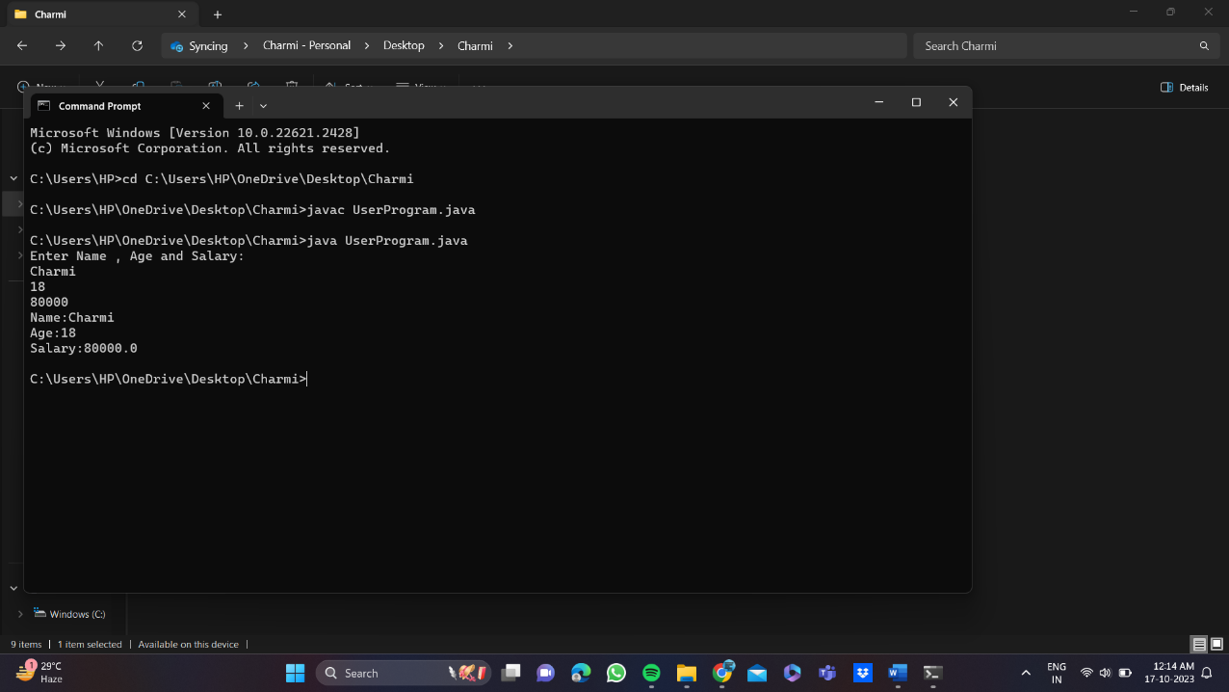

**2} Buffer reader class**

package com.javatpoint;

import java.io.*;

public class BufferedReaderExample{

public static void main(String args[])throws Exception{

InputStreamReader r=new InputStreamReader(System.in);

BufferedReader br=new BufferedReader(r);

System.out.println("Enter your name");

String name=br.readLine();

System.out.println("Welcome "+name);

}

}

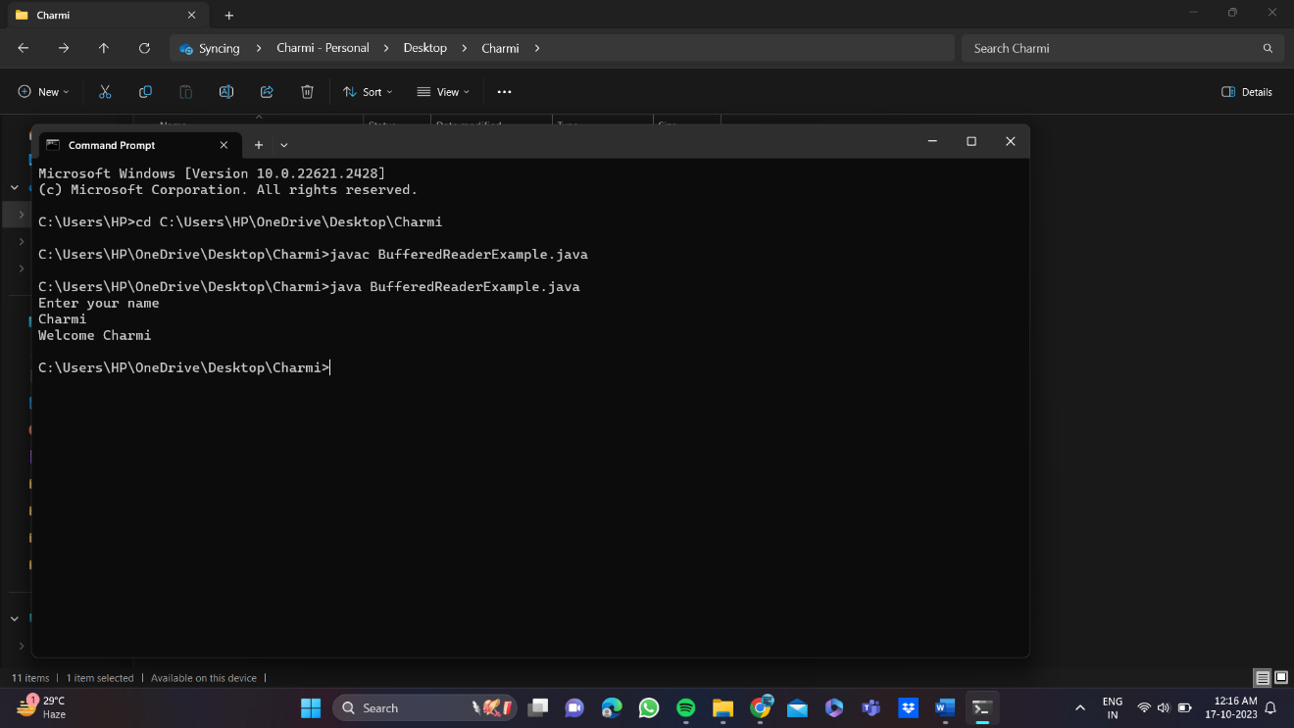

**Conclusion:**

1) Comment on how you have used BufferedReader and Scanner Class for accepting user input

* **BufferedReader:**BufferedReader is a class used for reading text from character-input streams. It's often used for reading user input from the console.It's typically wrapped around an InputStreamReader to read from standard input (System.in).BufferedReader is efficient for reading large volumes of text because it buffers the input, reducing the number of I/O operations.When you use BufferedReader, you can use its readLine() method to read a whole line of text as a String. This is useful for processing textual input.The readLine() method can throw an IOException, so it's essential to handle exceptions appropriately to ensure the program's robustness.
* **Scanner:** Scanner is a class that provides various methods for parsing different data types from an input source, including the console. It's convenient for parsing user input into different data types like integers, doubles, and strings. Scanner can tokenize input, breaking it into smaller pieces based on delimiters (default delimiter is whitespace). You can create a Scanner object to read from standard input (System.in), and then use methods like nextInt(), nextDouble(), and nextLine() to read specific data types. Scanner can be resource-intensive for reading large volumes of text because it's not as efficient as BufferedReader. It provides more user-friendly input methods that don't require explicit parsing like BufferedReader.

|  |
| --- |
| Experiment No. 3 |
| Implement a program that demonstrates the concepts of class and objects |
| Date of Performance: |
| Date of Submission: |

**Aim:** Implement a program that demonstrates the concepts of class and objects

**Objective:** To develop the ability of converting real time entity into objects and create their classes.

## Theory:

A class is a user defined blueprint or prototype from which objects are created.  It represents the set of properties i.e., members and methods that are common to all objects of one type. In general, class declarations can include these components, in order:

1. Modifiers: A class can be public or has default access.
2. class keyword: class keyword is used to create a class.
3. Class name: The name should begin with a initial letter (capitalized by convention).
4. Superclass (if any): The name of the class’s parent (superclass), if any, preceded by the keyword extends. A class can only extend (subclass) one parent.
5. Interfaces (if any): A comma-separated list of interfaces implemented by the class, if any, preceded by the keyword implements. A class can implement more than one interface.
6. Body: The class body surrounded by braces, {}.

An OBJECT is a basic unit of Object-Oriented Programming and represents the real-life entities.  A typical Java program creates many objects, which interact by invoking methods. An object consists of:

1. State: It is represented by attributes of an object. It also reflects the properties of an object.
2. Behavior: It is represented by methods of an object. It also reflects the response of an object with other objects.
3. Identity: It gives a unique name to an object and enables one object to interact with other objects.

**Code:**

**1}**

class Rectangle{

int length;

int width;

void insert(int l, int w){

length=l;

width=w;

}

void calculateArea(){System.out.println(length*width);}

}

class TestRectangle1{

public static void main(String args[]){

Rectangle r1=new Rectangle();

Rectangle r2=new Rectangle();

r1.insert(7,9);

r2.insert(5,12);

r1.calculateArea();

r2.calculateArea();

}

}

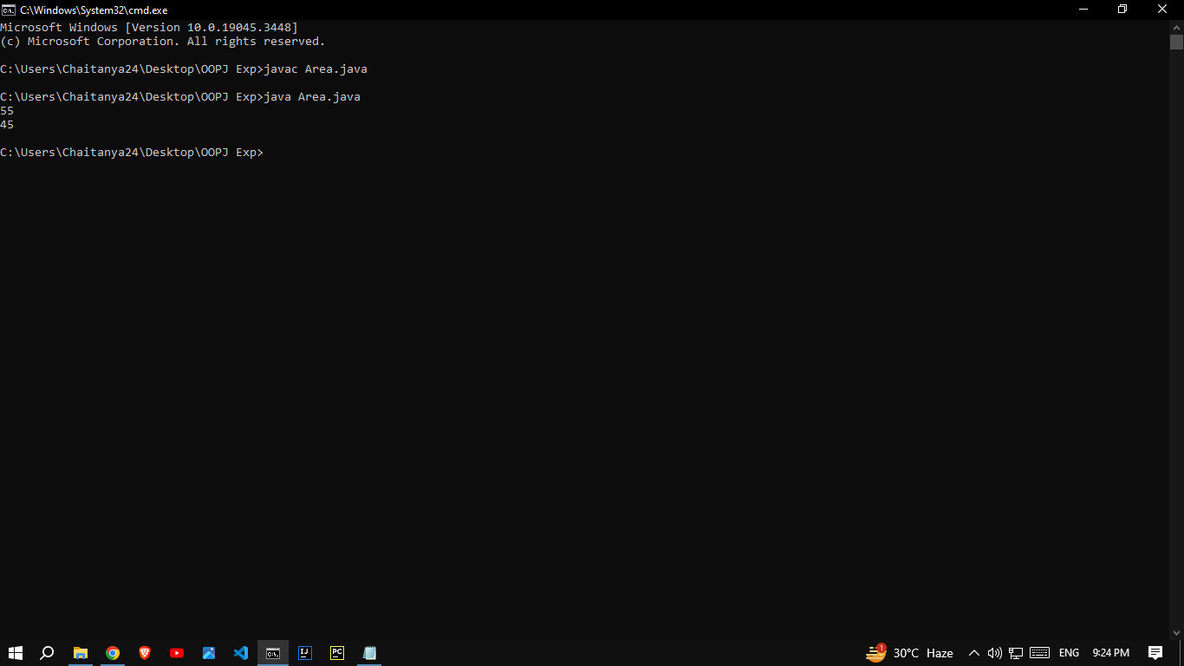

## Conclusion:

1) Comment on how you create a class template and their objects.

**Class Template**:

* A class in Java is a blueprint that defines the structure and behavior of objects.
* It includes attributes (fields) and methods.
* Provides encapsulation, encapsulating data and methods within a unit.

**Creating Objects**:

* Objects are instances of a class created using the **new** keyword.
* Multiple objects can be created from the same class.
* Objects have their own set of attributes and can interact with each other through methods.

**Benefits**:

* Reusability: Classes promote code reuse.
* Modularity: Classes break down a program into manageable units.
* Abstraction: Classes hide internal details and expose necessary functionality.
* Data Integrity: Encapsulation ensures data consistency and reliability.

In summary, classes are used to create objects, which are self-contained units with attributes and behavior, promoting organized and maintainable code in Java.

|  |
| --- |
| Experiment No. 4 |
| Implement a program on method and constructor overloading. |
| Date of Performance: |
| Date of Submission: |

**Aim:** Implement a program on method and constructor overloading.

**Objective:** To use concept of method overloading in a java program to create a class with same function name with different number of parameters.

## Theory:

Method Overloading is a feature that allows a class to have more than one method having the same name, if their argument lists are different. It is similar to constructor overloading in Java, that allows a class to have more than one constructor having different argument lists.

Example: This example to show how method overloading is done by having different number of parameters for the same method name.

Class DisplayOverloading

{

public void disp(char c)

{

System.out.println(c);

}

public void disp(char c, int num)

{

System.out.println(c + “ “+num);

}

}

Class Sample

{

Public static void main(String args[])

{

DisplayOverloading obj = new DisplayOverloading();

Obj.disp(‘a’);

Obj.disp(‘a’,10);

}

}

Output:

A

A 10

Java supports Constructor Overloading in addition to overloading methods. In Java, overloaded constructor is called based on the parameters specified when a [new](https://www.geeksforgeeks.org/new-operator-vs-newinstance-method-java/) is executed.

Sometimes there is a need of initializing an object in different ways. This can be done using constructor overloading.

For example, the Thread class has 8 types of constructors. If we do not want to specify anything about a thread then we can simply use the default constructor of the Thread class, however, if we need to specify the thread name, then we may call the parameterized constructor of the Thread class with a String args like this:

**Thread t= new Thread (" MyThread ");**

**Code:**

class Overload2

{

public static void main(String args[])

{

System.out.println(Add.add(5,4));

System.out.println(Add.add(2.80,3.12,9.00));

}

}

class Add{

static int add(int a,int b) {return a+b;}

static double add(double a,double b,double c) {return a+b+c;}

}

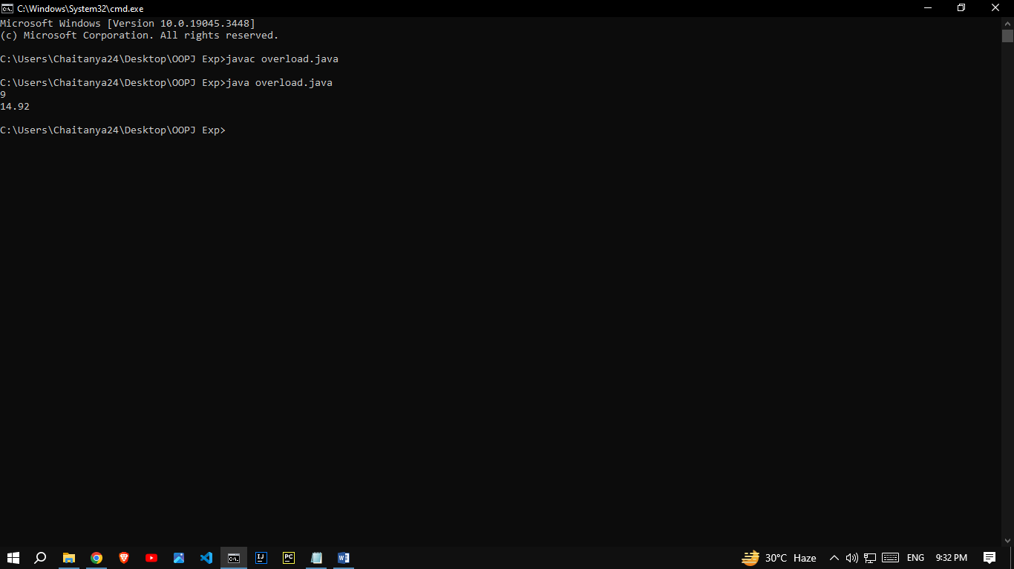

## Conclusion:

Comment on how function and constructor overloading used using java

**Function Overloading**:

1. **Definition**: Function overloading, also known as method overloading, is a feature in Java that allows you to define multiple methods within a class with the same name but different parameters.
2. **Parameter Lists**: The methods that are part of an overload set must differ in their parameter lists. This difference can involve the number of parameters, their types, or both.
3. **Compile-Time Polymorphism**: Function overloading is a form of compile-time polymorphism, where the compiler determines which method to call based on the arguments provided at the call site.

**Constructor Overloading:**

1. **Definition:** Constructor overloading is similar to function overloading, but it applies to constructors of a class. It allows you to define multiple constructors for a class with different parameter lists.
2. **Initialization:** Constructors are used to initialize the state of objects when they are created. Overloading constructors allows you to provide different ways to initialize objects of the same class.

In summary, function and constructor overloading in Java allows you to define multiple methods or constructors with the same name but different parameter lists, providing flexibility and improving code organization and readability. This feature is part of Java's polymorphism capabilities, enabling you to create more versatile and user-friendly classes and methods.

|  |
| --- |
| Experiment No. 5 |
| Implement a program on Packages. |
| Date of Performance: |
| Date of Submission: |

**Aim:** To use packages in java.

**Objective:** To use packages in java to use readymade classes available in them using square root method in math class.

## Theory:

A java package is a group of similar types of classes, interfaces and sub-packages. Packages are used in Java in order to prevent naming conflicts, to control access, to make searching/locating and usage of classes, interfaces, enumerations and annotations easier, etc.

There are two types of packages-

1. Built-in package: The already defined package like java.io.*, java.lang.* etc are known as built-in packages.
2. User defined package: The package we create for is called user-defined package.

Programmers can define their own packages to bundle group of classes/interfaces, etc. While creating a package, the user should choose a name for the package and include a package statement along with that name at the top of every source file that contains the classes, interfaces, enumerations, and annotation types that you want to include in the package. If a package statement is not used then the class, interfaces, enumerations, and annotation types will be placed in the current default package.

**Code:**

**1**//Save by A.java

package mypack;

public class A

{

public static void msg()

{

System.out.println("Welcome to Package!!");

}

}

//Save by B.java

package mypack;

import mypack.*;

class B

{

public static void main(String args[])

{

A obj=new A();

obj.msg();

}

}

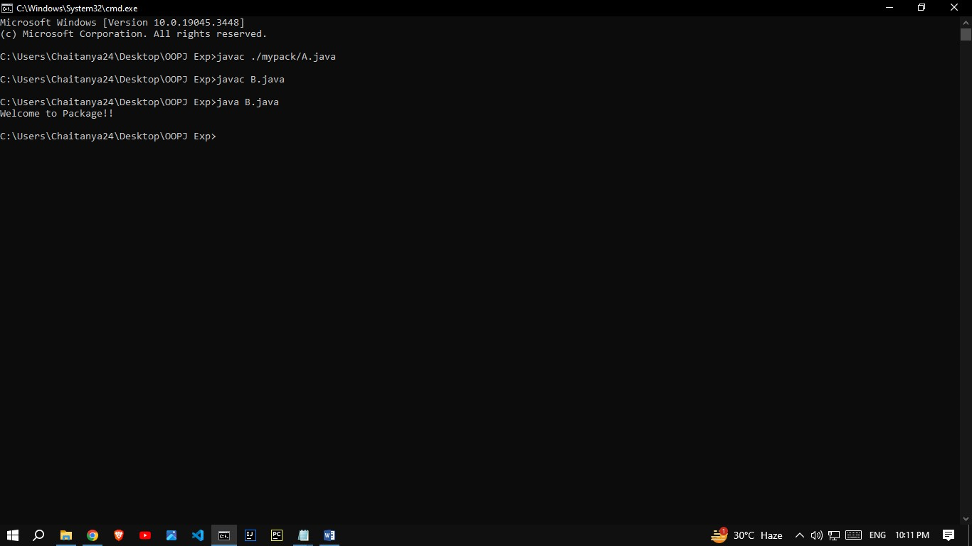

## Conclusion:

Comment on the autoencoder architecture and the Image compression results.

Autoencoders are neural networks used for data compression. They consist of an encoder to reduce data dimensions and a decoder to reconstruct the data. In Java, you can build an autoencoder for image compression. Results will include smaller-sized images that maintain essential features, useful for storage and transmission, but with some loss of detail due to the compression.

|  |
| --- |
| Experiment No. 6 |
| Implement a program on 2D array & strings functions. |
| Date of Performance: |
| Date of Submission: |

**Aim:** To use 2D arrays and Strings for solving given problem.

**Objective:**  To use 2D array concept and strings in java to solve real world problem

**Theory:**

* An array is used to store a fixed-size sequential collection of data of the same type.
* An array can be init in two ways:

1. Initializing at the time of declaration:

dataType[] myArray = {value0, value1, ..., valuek};

1. Dynamic declaration:

dataType[] myArray = new dataType[arraySize];

myArray[index] = value;

* Two – dimensional array is the simplest form of a multidimensional array. Data of only same data type can be stored in a 2D array.Data in a 2D Array is stored in a tabular manner which can be represented as a matrix.
* A 2D Array can be declared in 2 ways:

1. Intializing at the time of declaration:

dataType[][] myArray = { {valueR1C1, valueR1C2...}, {valueR2C1, valueR2C2...},..}

1. Dynamic declaration:

dataType[][] myArray = new dataType[x][y];

myArray[row_index][column_index] = value;

In [Java](https://www.javatpoint.com/java-tutorial), string is basically an object that represents sequence of char values. An [array](https://www.javatpoint.com/array-in-java) of characters works same as Java string. **Java String** class provides a lot of methods to perform operations on strings such as compare(), concat(), equals(), split(), length(), replace(), compareTo(), intern(), substring() etc.

### **1.String literal**

To make Java more memory efficient (because no new objects are created if it exists already in the string constant pool).

**Example:**

String demoString = “GeeksforGeeks”;

### **2. Using new keyword**

* String s = new String(“Welcome”);
* In such a case, JVM will create a new string object in normal (non-pool) heap memory and the literal “Welcome” will be placed in the string constant pool. The variable s will refer to the object in the heap (non-pool)

**Example:**

String demoString = new String (“GeeksforGeeks”);

**Code:**

**1}**

class Testarray3{

public static void main(String args[]){

int arr[][]={{1,2,3},{2,4,5},{4,4,5}};

for(int i=0;i<3;i++){

for(int j=0;j<3;j++){

System.out.print(arr[i][j]+" ");

}

System.out.println();

}

}}

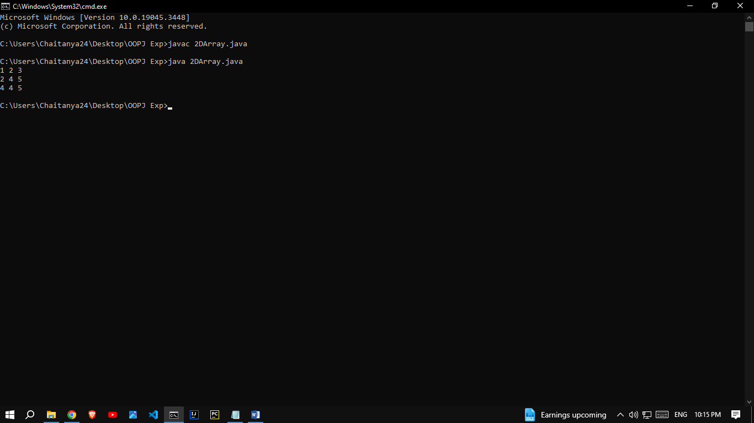

**2}**

class StringExample{

public static void main(String args[]){

String s1="java";

char ch[]={'s','t','r','i','n','g','s'};

String s2=new String(ch);

String s3=new String("example");

System.out.println(s2);

System.out.println(s3);

}}

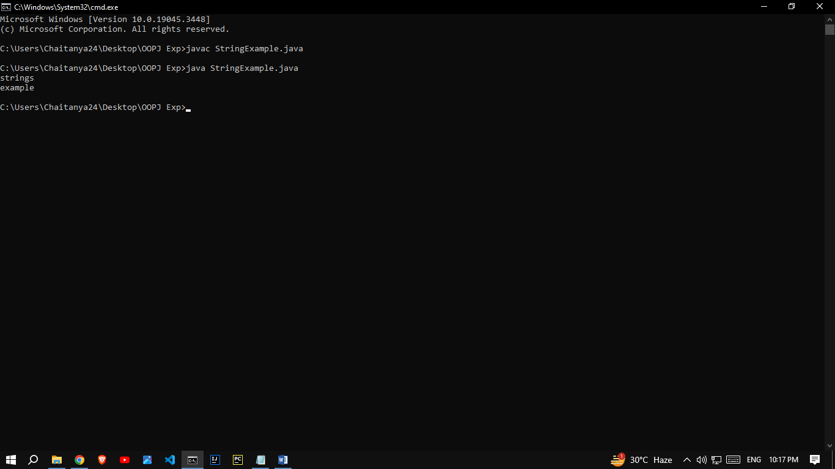

**Conclusion:**

Comment on how you have used the concept of string and 2D array.

String Usage:

String s1 = "java";: Here, we've created a string s1 using a string literal.

char ch[] = {'s','t','r','i','n','g','s'};: We've defined a character array ch, and then we've created a string s2 using this character array. This demonstrates the creation of a string from an array of characters.

String s3 = new String("example");: This is another way to create a string, using the new keyword and a constructor. We have created s3 from the string literal "example".

2D Array Usage:

int arr[][] = {{1,2,3},{2,4,5},{4,4,5}};: We defined a 2D integer array arr with three rows and three columns. This represents a 3x3 grid of integer values.

The nested loops (for loops) in the Testarray3 class are used to iterate through the elements of the 2D array and print them out. This demonstrates how to access and display elements from a 2D array.

|  |
| --- |
| Experiment No. 7 |
| Implement a program on single inheritance. |
| Date of Performance: |
| Date of Submission: |

**Aim:** To implement the concept of single inheritance.

**Objective:** Ability to design a base and child class relationship to increase reusability.

## Theory:

Single inheritance can be defined as a derived class to inherit the basic methods (data members and variables) and behaviour from a superclass. It’s a basic is-a relationship concept exists here. Basically, java only uses a single inheritance as a subclass cannot extend more superclass.

Inheritance is the basic properties of object-oriented programming. Inheritance tends to make use of the properties of a class object into another object. Java uses inheritance for the purpose of code-reusability to reduce time by then enhancing reliability and to achieve run time polymorphism. As the codes are reused it makes less development cost and maintenance. Java has different types of inheritance namely single inheritance, multilevel, multiple, hybrid. In this article, we shall go through on basic understanding of single inheritance concept briefly in java with a programming example. Here we shall have a complete implementation in java.

**Syntax:**

The general syntax for this is given below. The inheritance concepts use the keyword ‘extend’ to inherit a specific class. Here you will learn how to make use of extending keyword to derive a class. An extend keyword is declared after the class name followed by another class name. Syntax is,

class base class  
{…. methods  
}  
class derived class name extends base class  
{  
methods … along with this additional feature  
}  
Java uses a keyword ‘extends’ to make a new class that is derived from the existing class. The inherited class is termed as a base class or superclass, and the newly created class is called derived or subclass. The class which gives data members and methods known as the base class and the class which takes the methods is known as child class.

## Code:

**1}** class Animal{

void eat(){System.out.println("eating...");}

}

class Dog extends Animal{

void bark(){System.out.println("barking...");}

}

class TestInheritance{

public static void main(String args[]){

Dog d=new Dog();

d.bark();

d.eat();

}}

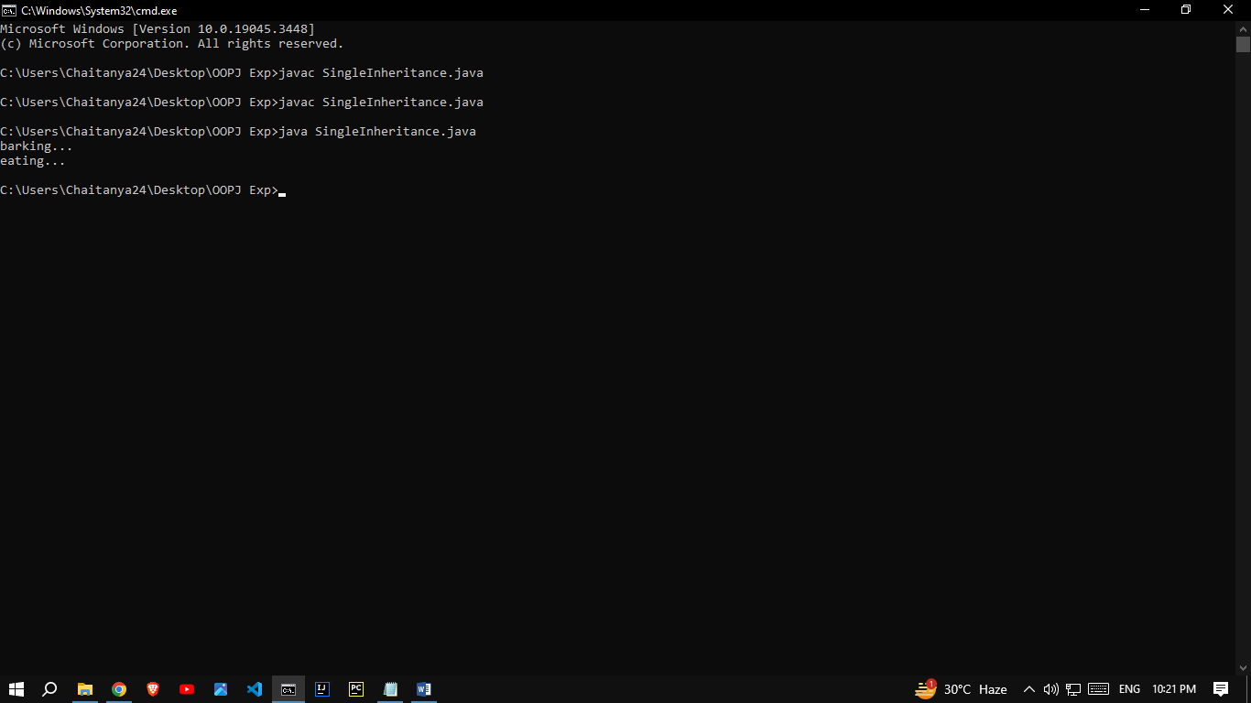

## Conclusion:

Comment on the Single inheritance.

In Java, single inheritance means a class can inherit properties and behaviors from only one superclass. This avoids ambiguity and simplifies class relationships, promoting code reusability and maintainability. Multiple inheritance is not directly supported in Java, but interfaces allow multiple inheritance of behavior. In summary, single inheritance in Java allows for a clear and structured approach to building class hierarchies, promoting code reusability, and avoiding ambiguity that can occur with multiple inheritance. It simplifies the relationships between classes and contributes to the maintainability of Java code.

|  |
| --- |
| Experiment No. 8 |
| Implement a program on multiple inheritance with interface. |
| Date of Performance: |
| Date of Submission: |

**Aim:** Implement a program on multiple inheritance with interface.

**Objective:** Implement multiple inheritance in a program to perform addition, multiplication and transpose operations on a matrix. Create an interface to hold prototypes of these methods and create a class input to read input. Inherit a new class from this interface and class. In main class create object of this child class and invoke required methods.

## Theory:

* In Multiple inheritance, one class can have more than one superclass and inherit features from all parent classes. Java does not support [multiple inheritance](https://www.geeksforgeeks.org/java-and-multiple-inheritance/) with classes. In java, we can achieve multiple inheritance only through [Interfaces](http://quiz.geeksforgeeks.org/interfaces-in-java/).
* An interface contains variables and methods like a class but the methods in an interface are abstract by default unlike a class. If a class implements multiple interfaces, or an interface extends multiple interfaces, it is known as multiple inheritance.
* However, Java supports multiple interface inheritance where an interface extends more than one super interfaces.
* A class implements an interface, but one interface extends another interface.Multiple inheritance by interface occurs if a class implements multiple interfaces or also if an interface itself extends multiple interfaces.
* The following is the syntax used to extend multiple interfaces in Java:

access_specifier interface subinterfaceName extends superinterface1, superinterface2, …… {

// Body  
}

**Code:**

class MultInherit{

public static void main(String args[])

{

Pig a=new Pig();

a.animalsound();

a.sleep();

}

}

interface Animal{

public void animalsound();

public void sleep();

}

class Pig implements Animal{

public void animalsound(){

System.out.println("The Pig says: wee-wee");

}

public void sleep(){

System.out.println("zzzzzzzz");

}

}

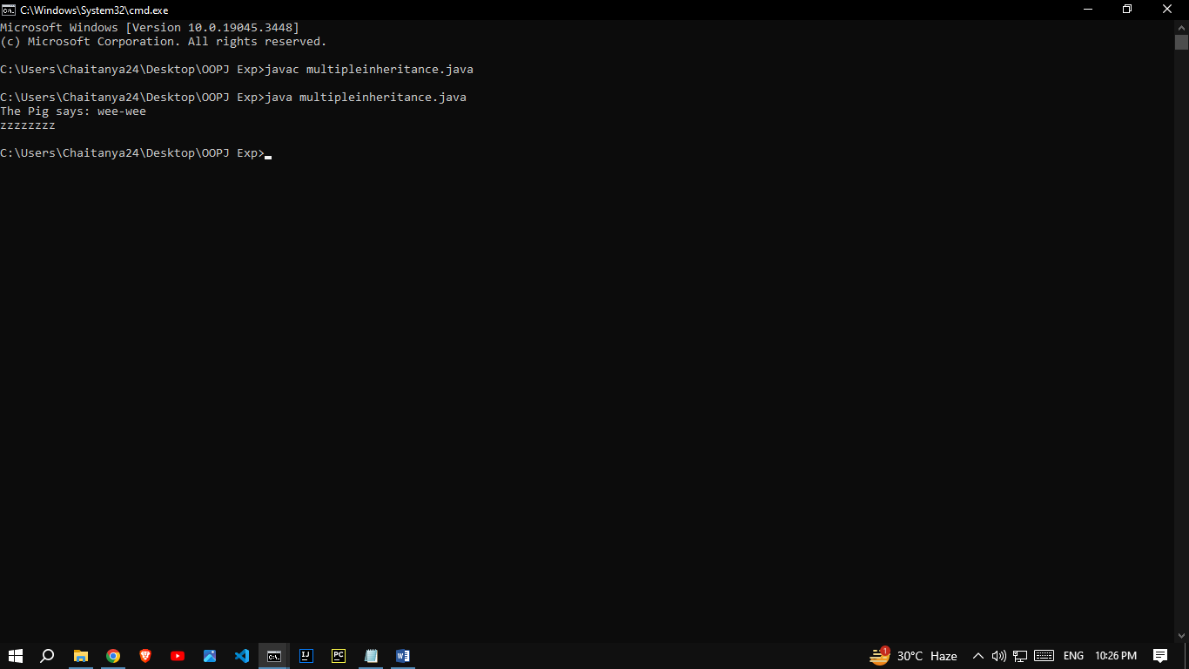

## Conclusion:

Comment on how interface are useful and implemented using java.

Interfaces in Java are a powerful feature that allows you to define a contract or a set of abstract methods that must be implemented by classes that implement the interface. They are useful for achieving multiple inheritance of behavior, creating flexible and extensible code, and enforcing a common API in Java. In summary, interfaces in Java are useful for defining contracts, achieving multiple inheritance of behavior, ensuring consistency, and enabling polymorphism. They are implemented by classes that provide concrete implementations of the methods defined in the interface, allowing for code extensibility and organization.

|  |
| --- |
| Experiment No. 9 |
| Implement a program on Exception handling. |
| Date of Performance: |
| Date of Submission: |

**Aim:** Implement a program on Exception handling.

**Objective**: To able handle exceptions occurred and handle them using appropriate keyword

## Theory:

The Exception Handling in Java is one of the powerful mechanisms to handle the runtime errors so that the normal flow of the application can be maintained.

Exception Handling is a mechanism to handle runtime errors such as ClassNotFoundException, IOException, SQLException, RemoteException, etc.

Java Exception Keywords

Java provides five keywords that are used to handle the exception. The following table describes each.

|  |  |
| --- | --- |
| **Keyword** | **Description** |
| try | The "try" keyword is used to specify a block where we should place an exception code. It means we can't use try block alone. The try block must be followed by either catch or finally. |
| catch | The "catch" block is used to handle the exception. It must be preceded by try block which means we can't use catch block alone. It can be followed by finally block later. |
| finally | The "finally" block is used to execute the necessary code of the program. It is executed whether an exception is handled or not. |
| throw | The "throw" keyword is used to throw an exception. |
| throws | The "throws" keyword is used to declare exceptions. It specifies that there may occur an exception in the method. It doesn't throw an exception. It is always used with method signature. |

## public class JavaExceptionExample{

## public static void main(String args[]){

## try{

## //code that may raise exception

## int data=100/0;

## 

## }catch(ArithmeticException e){System.out.println(e);}

## //rest code of the program

## System.out.println("rest of the code...");

## }

## }

**Output:**

Exception in thread main java.lang.ArithmeticException:/ by zero

rest of the code...

**Code:**

**1}** Try-catch

class Main2

{

public static void main(String args[])

{

try{

int divideByZero = 8/0;

System.out.println("Rest of code in try block");

}

catch (ArithmeticException e) {

System.out.println("ArithmeticException => " + e.getMessage());

}

}

}

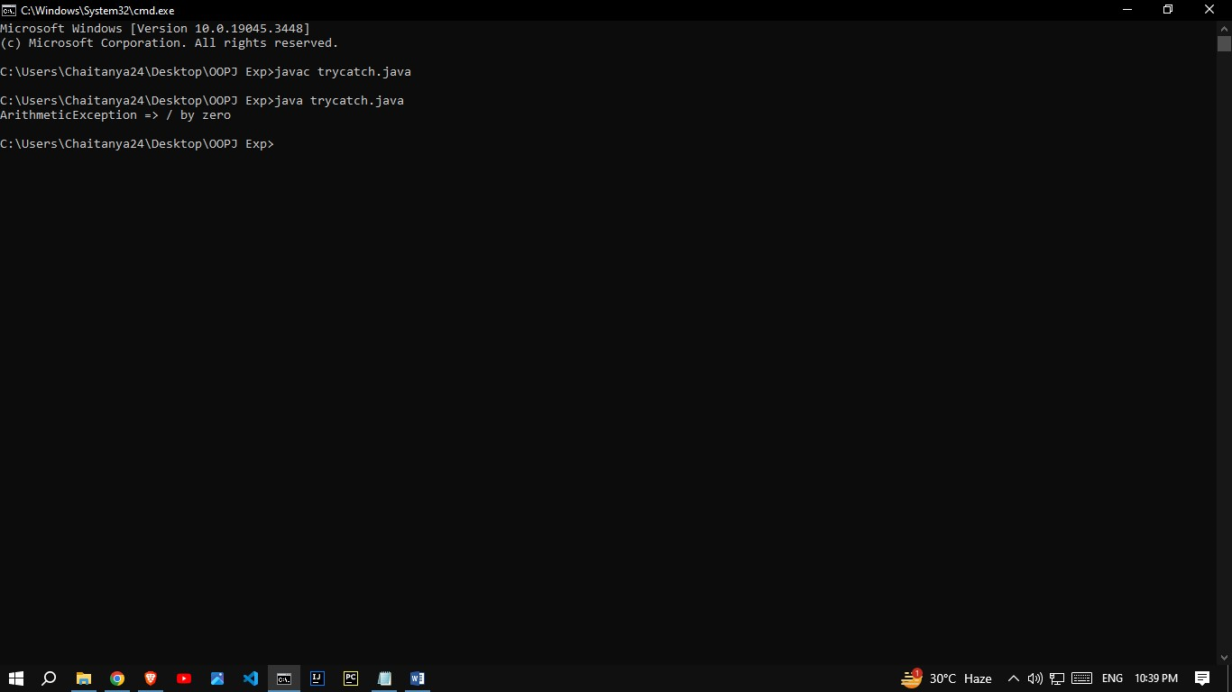

**2}** finally

class TestFinallyBlock {

public static void main(String args[]){

try{

int data=25/5;

System.out.println(data);

}

catch(NullPointerException e){

System.out.println(e);

}

finally {

System.out.println("finally block is always executed");

}

System.out.println("rest of phe code...");

}

}

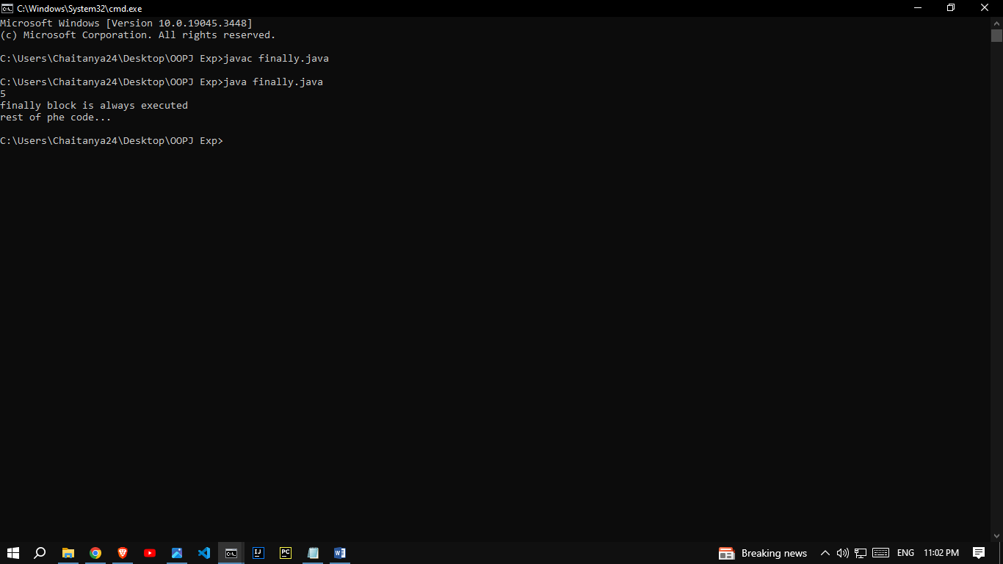

**3}**throws

import java.io.IOException;

class Testthrows2{

public static void main(String args[]){

try{

M m=new M();

m.method();

}catch(Exception e){System.out.println("exception handled");}

System.out.println("normal flow...");

}

}

class M {

void method() throws IOException {

throw new IOException("device error");

}

}

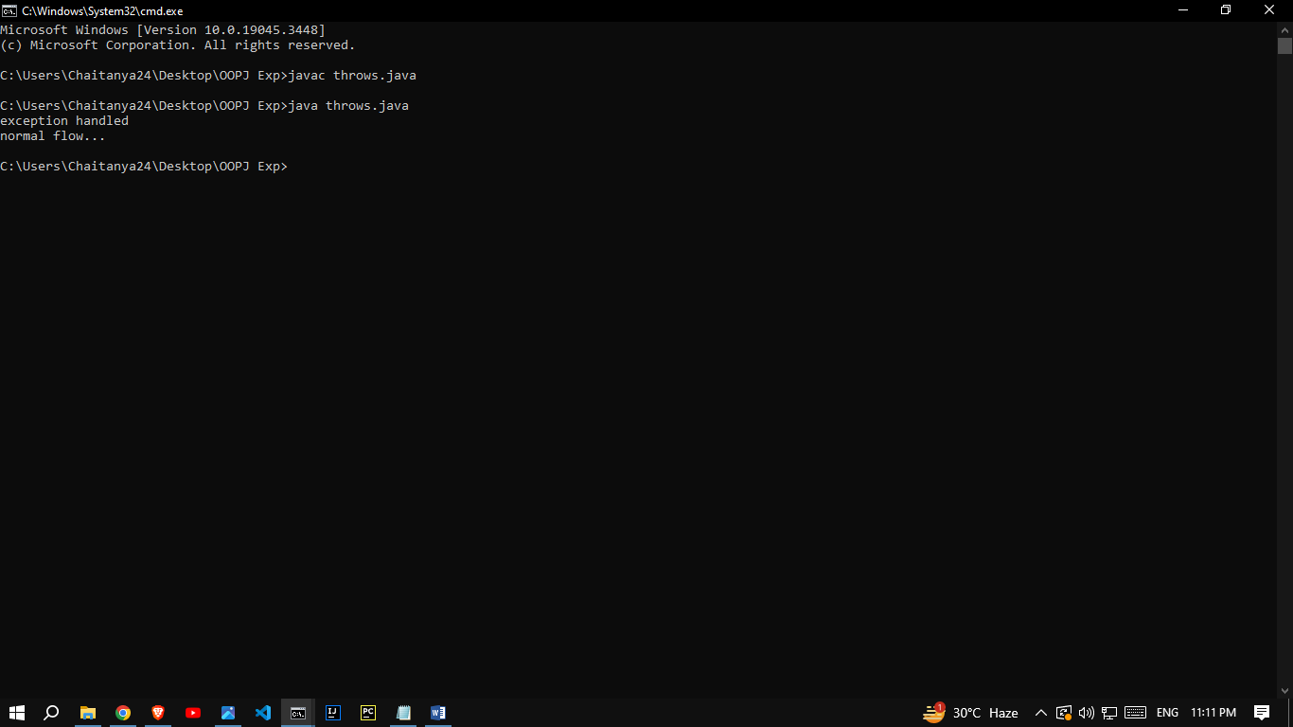

**4}** throw

class TestThrow3

{

public static void main(String args[])

{

try

{

throw new UserDefinedException("This is user-defined exception");

}

catch (UserDefinedException ude)

{

System.out.println("Caught the exception");

System.out.println(ude.getMessage());

}

}

}

class UserDefinedException extends Exception

{

public UserDefinedException(String str)

{

super(str);

}

}

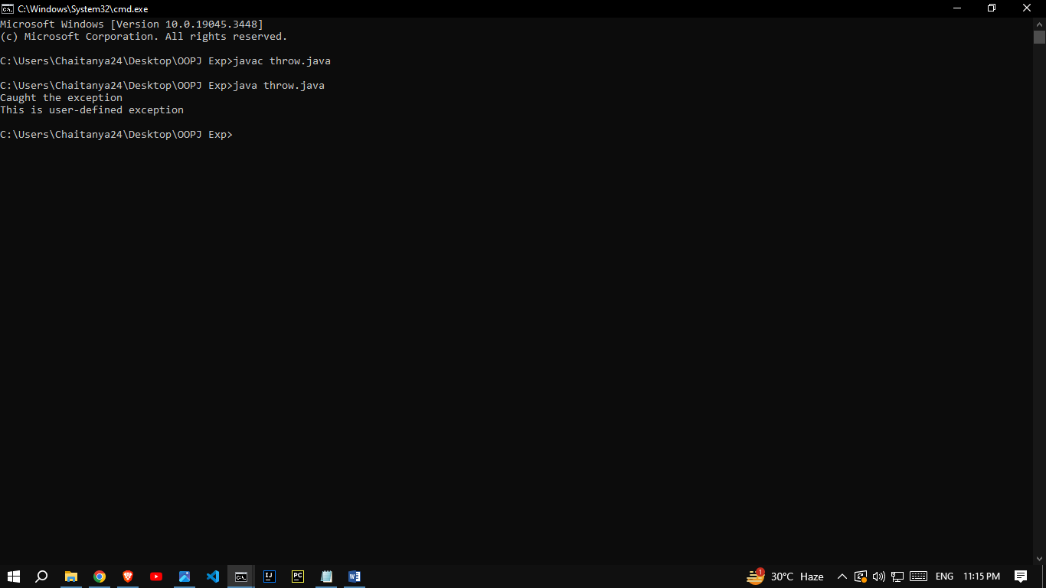

## Conclusion:

Comment on how exceptions are handled in JAVA.

In Java, exceptions are handled using a combination of the try, catch, finally, and throw keywords. Exception handling is a crucial aspect of Java programming, as it allows you to gracefully deal with runtime errors and maintain the stability and reliability of your programs.

Java handles exceptions through a structured mechanism:

* Exceptions can be categorized as checked (must be caught or declared) and unchecked.
* Exceptions are caught and handled using **try-catch** blocks.
* The **finally** block allows for cleanup or resource release.
* Custom exceptions can be created for application-specific errors.
* Use specific exceptions, log them, and close resources properly.
* Java provides a robust way to handle errors and improve code reliability.

|  |
| --- |
| Experiment No. 10 |
| Implement program on Multithreading |
| Date of Performance: |
| Date of Submission: |

**Aim:** Implement program on Multithreading

**Objective**:

## Theory:

**Multithreading in**[**Java**](https://www.javatpoint.com/java-tutorial) is a process of executing multiple threads simultaneously.

A thread is a lightweight sub-process, the smallest unit of processing. Multiprocessing and multithreading, both are used to achieve multitasking.

However, we use multithreading than multiprocessing because threads use a shared memory area. They don't allocate separate memory area so saves memory, and context-switching between the threads takes less time than process.

Java Multithreading is mostly used in games, animation, etc.

Java provides **Thread class** to achieve thread programming. Thread class provides [constructors](https://www.javatpoint.com/java-constructor) and methods to create and perform operations on a thread. Thread class extends [Object class](https://www.javatpoint.com/object-class) and implements Runnable interface.

There are two ways to create a thread:

1. By extending Thread class
2. By implementing Runnable interface.

### **Thread class:**

Thread class provide constructors and methods to create and perform operations on a thread.Thread class extends Object class and implements Runnable interface.

### **1) Java Thread Example by extending Thread class**

**FileName:** Multi.java

**class** Multi **extends** Thread{

**public** **void** run(){

System.out.println("thread is running...");

}

**public** **static** **void** main(String args[]){

Multi t1=**new** Multi();

t1.start();

 }

}

**Output:**

thread is running...

### **2) Java Thread Example by implementing Runnable interface**

**FileName:** Multi3.java

**class** Multi3 **implements** Runnable{

**public** **void** run(){

System.out.println("thread is running...");

}

**public** **static** **void** main(String args[]){

Multi3 m1=**new** Multi3();

Thread t1 =**new** Thread(m1);   // Using the constructor Thread(Runnable r)

t1.start();

 }

}

**Output:**

thread is running...

**Code:**

class Multi2 implements Runnable{

public void run()

{

int a=5;

int b=7;

int c=a+b;

System.out.println("Addition :"+c);

}

public static void main(String args[]){

Multi2 m1=new Multi2();

Thread t1=new Thread(m1);

t1.start();

}

}

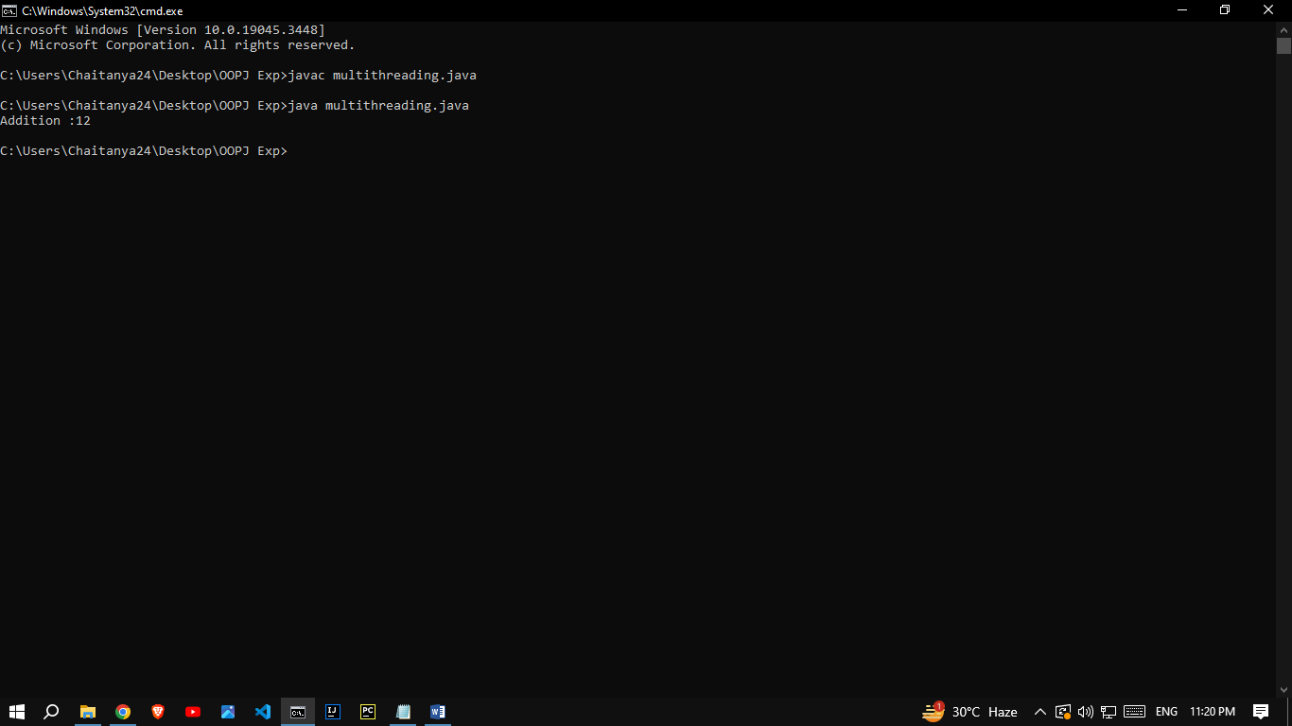

## Conclusion:

Comment on how multithreading is supported in JAVA.

Multithreading is a fundamental feature in Java, allowing you to write concurrent and parallel programs. Java provides built-in support for multithreading through its **java.lang.Thread** class and various synchronization mechanisms. In summary, Java provides comprehensive support for multithreading, making it relatively easy to write concurrent and parallel programs. You can create, manage, and synchronize threads using built-in language features and standard library classes, enabling the development of efficient and scalable applications.

|  |
| --- |
| Experiment No. 11 |
| Implement a program on Applet or AWT Controls |
| Date of Performance: |
| Date of Submission: |

**Aim:** Implement a program on Applet or AWT Controls

**Objective**:

To develop application like Calculator, Games, Animation using AWT Controls.

## Theory:

Java AWT (Abstract Window Toolkit) is an API to develop Graphical User Interface (GUI) or windows-based applications in Java.

Java AWT components are platform-dependent i.e. components are displayed according to the view of operating system. AWT is heavy weight i.e. its components are using the resources of underlying operating system (OS).

The java.awt  [package](https://www.javatpoint.com/package) provides [classes](https://www.javatpoint.com/object-and-class-in-java) for AWT API such as [TextField](https://www.javatpoint.com/java-awt-textfield), [Label](https://www.javatpoint.com/java-awt-label), [TextArea](https://www.javatpoint.com/java-awt-textarea), RadioButton, [CheckBox](https://www.javatpoint.com/java-awt-checkbox), [Choice](https://www.javatpoint.com/java-awt-choice), [List](https://www.javatpoint.com/java-awt-list) etc.

1. A general interface between Java and the native system, used for windowing, events and layout managers. This API is at the core of Java GUI programming and is also used by Swing and Java 2D. It contains the interface between the native windowing system and the Java application1.
2. A basic set of GUI widgets such as buttons, text boxes, and menus1. AWT also provides Graphics and imaging tools, such as shape, color, and font classes2. AWT also avails layout managers which helps in increasing the flexibility of the window layouts2

Java AWT calls the native platform calls the native platform (operating systems) subroutine for creating API components like TextField, ChechBox, button, etc.

For example, an AWT GUI with components like TextField, label and button will have different look and feel for the different platforms like Windows, MAC OS, and Unix. The reason for this is the platforms have different view for their native components and AWT directly calls the native subroutine that creates those components.

In simple words, an AWT application will look like a windows application in Windows OS whereas it will look like a Mac application in the MAC OS.

**Java AWT Hierarchy**

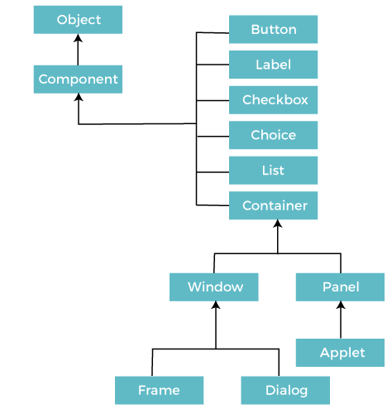

**Code:**

import javax.swing.*;

import java.awt.*;

import java.awt.event.*;

public class GFG {

public static void converter()

{

JFrame f = new JFrame("CONVERTER");

JLabel l1, l2;

JTextField t1, t2;

JButton b1, b2, b3;

l1 = new JLabel("Rupees:");

l1.setBounds(20, 40, 60, 30);

l2 = new JLabel("Dollars:");

l2.setBounds(170, 40, 60, 30);

t1 = new JTextField("0");

t1.setBounds(80, 40, 50, 30);

t2 = new JTextField("0");

t2.setBounds(240, 40, 50, 30);

b1 = new JButton("INR");

b1.setBounds(50, 80, 60, 15);

b2 = new JButton("Dollar");

b2.setBounds(190, 80, 60, 15);

b3 = new JButton("close");

b3.setBounds(150, 150, 60, 30);

b1.addActionListener(new ActionListener() {

public void actionPerformed(ActionEvent e)

{

double d

= Double.parseDouble(t1.getText());

double d1 = (d / 83.24);

String str1 = String.valueOf(d1);

t2.setText(str1);

}

});

b2.addActionListener(new ActionListener() {

public void actionPerformed(ActionEvent e)

{

double d2

= Double.parseDouble(t2.getText());

double d3 = (d2 * 83.24);

String str2 = String.valueOf(d3);

t1.setText(str2);

}

});

b3.addActionListener(new ActionListener() {

public void actionPerformed(ActionEvent e)

{

f.dispose();

}

});

f.addWindowListener(new WindowAdapter() {

public void windowClosing(WindowEvent e)

{

System.exit(0);

}

});

f.add(l1);

f.add(t1);

f.add(l2);

f.add(t2);

f.add(b1);

f.add(b2);

f.add(b3);

f.setLayout(null);

f.setSize(400, 300);

f.setVisible(true);

}

public static void main(String args[])

{

converter();

} }

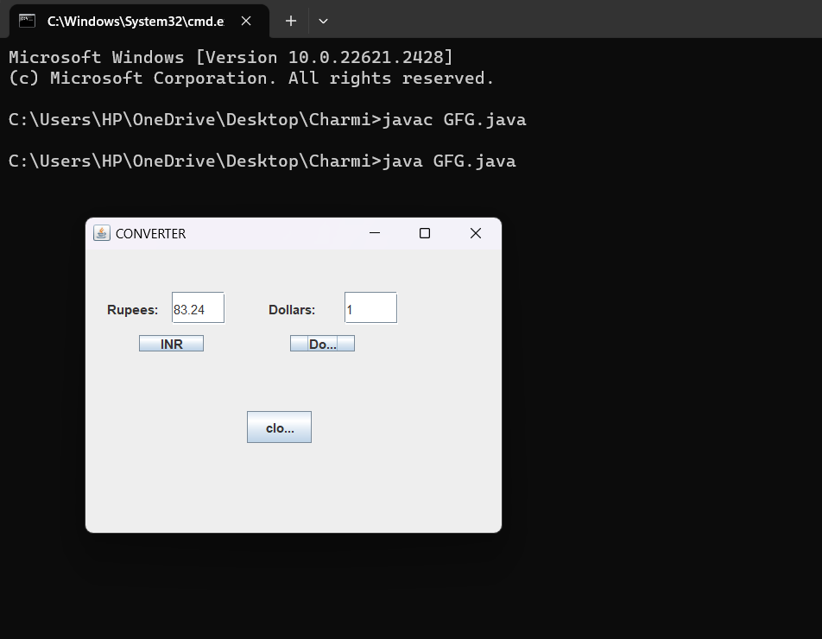

## Conclusion:

Comment on application development using AWT Controls.

Application development using AWT (Abstract Window Toolkit) controls in Java involves creating graphical user interfaces (GUIs) for desktop applications. AWT provides a set of basic GUI components, such as buttons, labels, text fields, and more. Here's a brief overview:

1. AWT Controls: AWT offers GUI controls for building your application's user interface.

2. Layout Managers: AWT provides layout managers to arrange and position controls within your GUI.

3. Customization: You can customize the appearance and behavior of AWT controls.

4. Platform Independence: AWT is platform-independent but may not provide the most modern look and feel.

5. Window and Frame: AWT allows you to create top-level containers (e.g., `Frame`) as the main windows for your application.

|  |
| --- |
| Experiment No. 12 |
| Course Project based on the content of the syllabus. |
| Date of Performance: |
| Date of Submission: |